FILED BY SKYWORKS SOLUTIONS, INC.
PURSUANT TO RULE 425 UNDER THE SECURITIES ACT OF 1933
AND DEEMED FILED PURSUANT TO RULE 14a-12 AND RULE 14d-2(b)
UNDER THE SECURITIES EXCHANGE ACT OF 1934
SUBJECT COMPANY: QORVO, INC.
COMMISSION FILE NO. 333-291947

On July 28, 2026, Skyworks Solutions, Inc. published the following on LinkedIn:

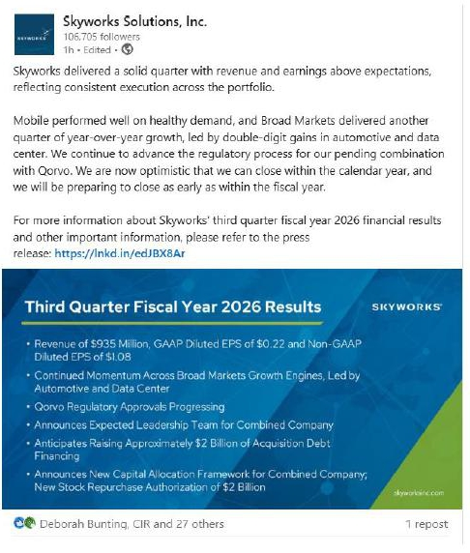

Important Information About the Proposed Transaction and Where to Find It

In connection with the proposed mergers (the “Mergers”) with Qorvo, Inc. (“Qorvo”), Skyworks has filed with the SEC a registration statement on Form S-4 (File No. 333-291947) (the “Registration Statement”), which includes a prospectus with respect to the shares of Skyworks’ common stock to be issued in the Mergers and a joint proxy statement for Skyworks’ and Qorvo’s respective stockholders (the “Joint Proxy Statement/Prospectus”). The Registration Statement was declared effective on December 23, 2025, and Skyworks filed a final prospectus on December 23, 2025, and Qorvo filed a definitive proxy statement on December 23, 2025. The Joint Proxy Statement/Prospectus was mailed to stockholders of Skyworks and Qorvo on or about December 23, 2025. Each of Skyworks and Qorvo may also file with or furnish to the SEC other relevant documents regarding the Mergers. This communication is not a substitute for the Registration Statement, the Joint Proxy Statement/Prospectus or any other document that Skyworks or Qorvo may mail to their respective stockholders in connection with the Mergers.

INVESTORS AND SECURITY HOLDERS OF SKYWORKS AND QORVO ARE URGED TO READ THE REGISTRATION STATEMENT AND THE JOINT PROXY STATEMENT/PROSPECTUS INCLUDED WITHIN THE REGISTRATION STATEMENT, AS WELL AS ANY OTHER RELEVANT DOCUMENTS FILED WITH THE SEC IN CONNECTION WITH THE MERGERS OR INCORPORATED BY REFERENCE INTO THE REGISTRATION STATEMENT AND THE JOINT PROXY STATEMENT/PROSPECTUS (INCLUDING ANY AMENDMENTS OR SUPPLEMENTS THERETO), BECAUSE THEY WILL CONTAIN IMPORTANT INFORMATION REGARDING SKYWORKS, QORVO, THE MERGERS AND RELATED MATTERS.

The documents filed by Skyworks with the SEC also may be obtained free of charge at Skyworks’ website at https://www.skyworksinc.com/investors or upon written request to Skyworks at investor.relations@skyworksinc.com. The documents filed by Qorvo with the SEC also may be obtained free of charge at Qorvo’s website at https://ir.qorvo.com/ or upon written request to Qorvo at investor-relations@qorvo.com. These documents filed with the SEC are also available for free to the public at the website maintained by the SEC at www.sec.gov.

No Offer or Solicitation

This communication is for informational purposes only and does not constitute, or form a part of, an offer to sell or the solicitation of an offer to buy any securities or a solicitation of any vote or approval, nor shall there be any sale of securities in any jurisdiction in which such offer, solicitation or sale would be unlawful prior to registration or qualification under the securities laws of any such jurisdiction. No offer of securities shall be made except by means of a prospectus meeting the requirements of Section 10 of the Securities Act of 1933, as amended, and otherwise in accordance with applicable law.

Cautionary Statement Regarding Forward-Looking Statements

This document contains “forward-looking statements” within the meaning of the federal securities laws, including Section 27A of the U.S. Securities Act of 1933, as amended, and Section 21E of the Securities Exchange Act of 1934, as amended. These forward-looking statements are based on Skyworks’ and Qorvo’s current expectations, estimates and projections about the expected date of closing of the proposed transaction and the potential benefits thereof, their respective businesses and industries, management’s beliefs and certain assumptions made by Skyworks and Qorvo, all of which are subject to change. In this context, forward-looking statements often address expected future business and financial performance and financial condition, and often contain words such as “expect,” “anticipate,” “intend,” “plan,” “believe,” “could,” “seek,” “see,” “will,” “may,” “would,” “might,” “potentially,” “estimate,” “continue,” “expect,” “target,” similar expressions or the negatives of these words or other comparable terminology that convey uncertainty of future events or outcomes. All forward-looking statements by their nature address matters that involve risks and uncertainties, many of which are beyond our control and are not guarantees of future results, such as statements about the consummation of the proposed transaction and the anticipated benefits thereof. These and other forward-looking statements, including the failure to consummate the proposed transaction or to make or take any filing or other action required to consummate the transaction in a timely matter or at all, are not guarantees of future results and are subject to risks, uncertainties and assumptions that could cause actual results to differ materially from those expressed in any forward-looking statements. Accordingly, there are or will be important factors that could cause actual results to differ materially from those indicated in such statements and, therefore, you should not place undue reliance on any such statements and caution must be exercised in relying on forward-looking statements. Important risk factors that may cause such a difference include, but are not limited to: (i) the completion of the proposed transaction on anticipated terms and timing, including obtaining regulatory approvals, anticipated tax treatment, unforeseen liabilities, future capital expenditures, revenues, expenses, earnings, synergies, economic performance, indebtedness, financial condition, losses, future prospects, business and management strategies, expansion and growth of Skyworks’ and Qorvo’s businesses and other conditions to the completion of the proposed transaction; (ii) failure to realize the anticipated benefits of the proposed transaction, including as a result of delay in completing the transaction or integrating the businesses of Skyworks and Qorvo; (iii) Skyworks’ and Qorvo’s ability to implement their business strategies; (iv) pricing trends; (v) potential litigation relating to the proposed transaction that has been or could be instituted against Skyworks, Qorvo or their respective directors; (vi) the risk that disruptions from the proposed transaction will harm Skyworks’ or Qorvo’s business, including current plans and operations; (vii) the ability of Skyworks or Qorvo to retain and hire key personnel; (viii) potential adverse reactions or changes to business relationships resulting from the announcement, pendency or completion of the proposed transaction; (ix) uncertainty as to the long-term value of Skyworks’ common stock; (x) legislative, regulatory and economic developments affecting Skyworks’ and Qorvo’s businesses; (xi) general economic and market developments and conditions; (xii) the evolving legal, regulatory and tax regimes under which Skyworks and Qorvo operate; (xiii) potential business uncertainty, including changes to existing business relationships, during the pendency of the proposed transaction that could affect Skyworks’ or Qorvo’s financial performance; (xiv) restrictions during the pendency of the proposed transaction that may impact Skyworks’ or Qorvo’s ability to pursue certain business opportunities or strategic transactions; and (xv) unpredictability and severity of catastrophic events, including, but not limited to, acts of terrorism or outbreak of war or hostilities, as well as Skyworks’ and Qorvo’s response to any of the aforementioned factors. These risks, as well as other risks associated with the proposed transaction, are more fully discussed in the Joint Proxy Statement/Prospectus. While the list of factors presented here and in the Joint Proxy Statement/Prospectus are considered representative, no such list should be considered to be a complete statement of all potential risks and uncertainties. Unlisted factors may present significant additional obstacles to the realization of forward looking statements. Consequences of material differences in results as compared with those anticipated in the forward-looking statements could include, among other things, business disruption, operational problems, financial loss, legal liability to third parties and similar risks, any of which could have a material adverse effect on Skyworks’ or Qorvo’s consolidated financial condition, results of operations or liquidity. Neither Skyworks nor Qorvo assumes any obligation to publicly provide revisions or updates to any forward-looking statements, whether as a result of new information, future developments or otherwise, should circumstances change, except as otherwise required by securities and other applicable laws.

